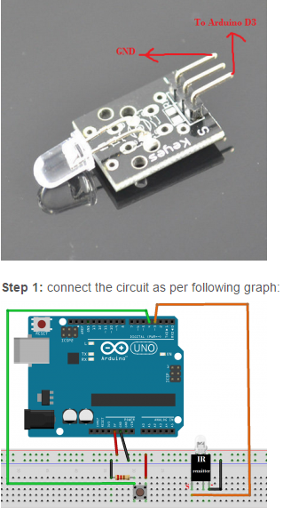
Step 2 – If you don’t have IRremote library, Download IRremote Library, and then import the library into Arduino IDE(in Arduino IDE->Sketch->Import Library->Add Library). If you have already installed this library, please skip this step.
Step 3: Download the sample code and load it into Arduino.
Step 4: run both IR remoter receiver project and this project. push switch button in transmitter circuit, the LED on receiver circuit will be turn on. Push the switch button again, the LED will be turn off.

